**System of Care: St. Louis Region Expansion (SOC Expansion)**

Parent & Youth Advisory Council (PYAC)

Engagement Packet



314-534-6015 | 1000 N. Vandeventer Ave. St. Louis, MO. 63113 | www.visionforchildren.org

# Getting to Know Us

About System of Care expansion

SOC Expansion (System of Care-St. Louis Region Expansion) is working to improve mental health outcomes for children and youth, birth through age 21, with serious emotional disturbances (SED), and their families by creating sustainable infrastructure and services. We serve juvenile justice involved youth ages 12-18 with SED and those with early signs and symptoms of Serious Mental Illness who live in St. Louis’s Promise Zone.

We are doing this by:

* Strengthening and enhancing current infrastructure to connect juvenile justice involved youth and families with mental health service providers and Family Support Partners (FSPs) by utilizing the existing SOC Linkage and Referral platform.
* Connecting juvenile justice involved youth and families with a cohort of FSPs to support families as they connect to and navigate mental health services in institutions and the community.
* FSPs are working with Courts to conduct outreach to families who have been identified as likely matches for the focus population criteria.
* FSPs are conducting outreach in the Promise Zone through partnerships with existing agencies that serve the focus population.

About Vision for Children at Risk

Vision for Children at Risk (VCR) promotes the well-being of children, youth, and their families, with a primary focus on those impacted by socioeconomic risk and racial inequity.

We do this by:

1. Informing the community with data and research,
2. Promoting collaborative action,
3. Engaging and supporting families, and
4. Advocating for child well-being through policy and community investment.

Our Core Values:

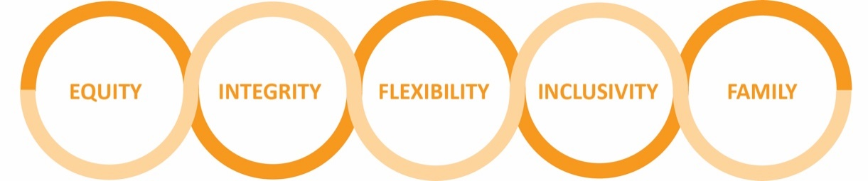

1

About the parent & Youth advisory council

The SOC Expansion Parent and Youth Advisory Council (SOC Expansion PYAC) exists to give parents a seat at the community table, before decisions about their community are made. SOC Expansion PYAC aims to provide parents and youth who are affected or interested in a decision; to find out more information, share their ideas, concerns, and needs. To make sure the best possible outcomes are achieved.

The PYAC’s decisions can have a wide impact, extending to all communities in St. Louis. It is therefore important to listen to a broad range of voices, to make sure decisions meet current and future needs. That’s why we want to engage the whole community.

Rest assured; SOC Expansion will listen to you, to understand your experiences and ideas before a decision about a strategy, program or project is made. Depending on the subject; SOC Expansion PYAC will also listen to local service providers, businesses, and other levels of government. To get a better understanding of how a project will impact our community at-large.

how it all fits together

VCR is driving the use and implementation of Parent Advisory Councils (PACs) and Parent and Youth Advisory Councils (PYACs) as a tool for ensuring parents and families are at the center of decisions that impact them. The PYACs are designed to put leadership and decision-making power back in the hands of families, and to grow the impact of families by connecting them to a broader network of systems change makers.

Check out the image on the next page to see how these PACs and PYACs are all connected. Together families are able to have a great impact!

2

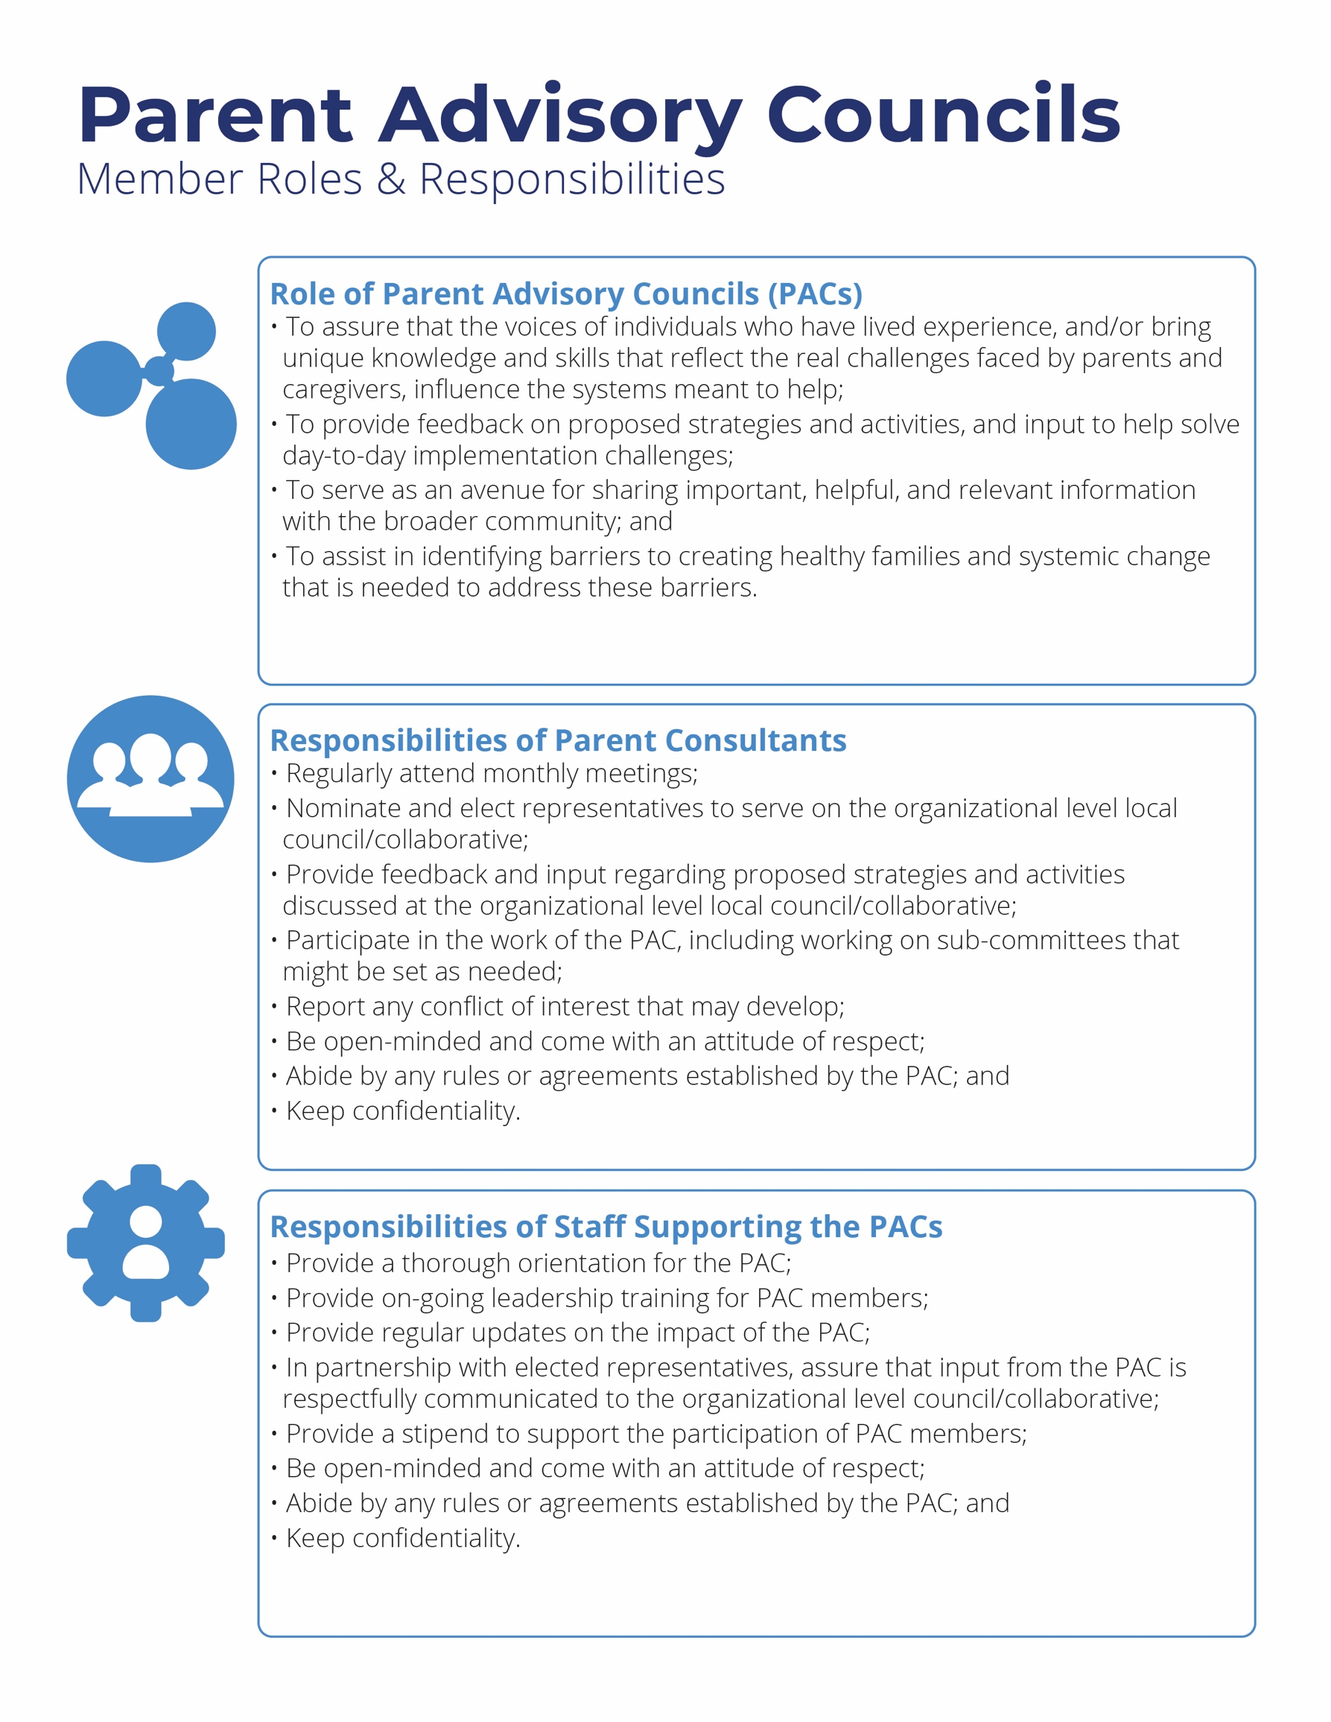

4

# Reducing the Barriers for Parent Involvement

We know you are busy and that your commitment to your kid(s) comes first. We seek to make it easy for you to participate.

* **Child Care**
  + We provide onsite child care for families that need it. Please connect with the VCR team before each meeting if this is something that would help you out. We utilize licensed providers only.
* **Parent Consultant Stipends**
  + Your time is important, and we know you are stepping away from other activities when you join us. We provide stipends for those that participate in our meetings and events.
* **Food:** 
  + Any event that is held over mealtimes will include free food. We know that time spent with us could be spent preparing meals for your family, so consider these events a meal on us.
* **Growth and Leadership Skill Development:** 
  + **We have ongoing opportunities for building skills that can be worthwhile to you as a Parent & Youth Advisory Council member and beyond.

# Get Involved!

To become a PYac parent or YOUTH Consultant with SOC Expansion:

1. Contact:

Jawana Hammonds

Director of Family Support Services

314-534-6015

jhammonds@visionforchildren.org

1. Sign our engagement agreement:

See form on the next page

5

# System of Care: St. Louis Region Expansion

# Parent & Youth Advisory Council (PYAC) Engagement Agreement

# Parent/Youth Consultant Information

Full name:

Address:

City: ______ Zip code: ____

Telephone: Email: ______

# Parent/Youth Consultant Compensation

The experience and expertise that parents and youth bring, is a tremendously appreciated. SOC Expansion parents and youth are compensated for their time, knowledge, and participation as consultants. Compensation is a fixed sum of $30 per meeting to cover time, active participation, and transportation.

# *Please note

Parents and youth are essential allies and partners in planning, implementing, evaluating, and training, related to SOC Expansion.

# Agreement

Signing this form, signifies that I will actively participate in the PYAC meetings by contributing and sharing ideas, even when my perspective differs from others. I agree to the consultant roles and responsibilities listed on page 4 of this document.

Signature: __________________________________________ Date_____________